VISVESVARAYA TECHNOLOGICAL UNIVERSITY
Jnana Sangama, Belagavi – 590018
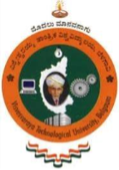

ALUMNI CONNECT

Submitted in partial fulfillment of the requirements as a part of the curriculum,

Bachelors of Engineering in Computer Science (Artificial Intelligence and Machine Learning)

Submitted by

ARSHITHA S 1CR24CI007

BHAVYASHREE PUPPALA 1CR24CI043

SMITHA C 1CR24CI058

Under the Guidance of
Priyanka S
Department of Artificial Intelligence and Machine Learning
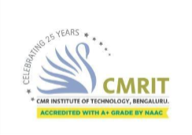

CMR INSTITUTE OF TECHNOLOGY
132, AECS Layout, Kundalahalli, ITPL Main Rd, Bengaluru – 560037


CERTIFICATE
Certified that the Mini Project entitled ALUMINI CONNECT is presented by
1. ARSHITHA S 1CR24CI007
2. BHAVYASHREE PUPPALA 1CR24CI043
3. SMITHA C 1CR24CI058

bonafide student(s) of CMR Institute of Technology in partial fulfilment of the requirements as a part of the curriculum, Bachelor of Engineering in Artificial Intelligence and Machine Learning, of Visvesvaraya Technological University, Belagavi during the year 2025-2026. It is certified that all correction/suggestion indicated for Internal Assessment have been incorporated in the report deposited in the departmental library. The Entrepreneurial Project report has been approved as it satisfies the academic requirements in respect of the Technical Seminar prescribed for the bachelor of engineering degree.

Priyanka S Dr. Shyam P Joy
Signature of the Guide Signature of the HOD

DECLARATION
We, the undersigned, students of CMR Institute of Technology, hereby declare that this mini project report title ALUMINI CONNECT is a record of our original work done under the supervision of Priyanka S, Department of CSE(AIML). And has not formed the basis of award of any other degree, in this or any other Institution or University. In keeping with the ethical practice in reporting scientific information, due acknowledgements have been made wherever the findings of others have been cited.

1. ARSHITHA S 1CR24CI007
2. BHAVYASHREE PUPPALA 1CR24CI043
3. SMITHA C 1CR24CI058

ABSTRACT
The Alumni Database and Interaction Portal is a web-based application developed to improve communication between alumni and students. Many institutions face difficulties in maintaining alumni records and providing a platform for interaction. Existing systems are often manual, outdated, and lack centralized access.

This project provides a centralized platform where alumni can register, update profiles, share achievements, and post job or internship opportunities. Students can search alumni details, interact with alumni, and explore career opportunities. The admin module helps in managing users and maintaining the database securely.

The system is developed using web technologies such as HTML, CSS, JavaScript, Node.js/Flask, and MySQL/MongoDB. The portal ensures secure login, easy accessibility, and efficient data management. The proposed system improves alumni-student networking and creates better career guidance opportunities for students.

ACKNOWLEDGEMENT
It is my proud privilege and duty to acknowledge the kind of help and guidance received from several people in preparation of this report. Apart from my own, the success of this report depends largely on the encouragement and guidelines of many others. It would have not been possible to prepare this report in this form without their valuable help, co-operation and guidance.
I would like to express my deep sense of gratitude to our Principal Dr. Sanjay Jain, CMR Institute of Technology, Bangalore for his motivation and for creating an inspiring atmosphere in college by providing state of the art facilities for preparation and delivery of this report.
My sincere thanks to Dr. Shyam P Joy, Head of Department of Artificial Intelligence and Machine Learning, for his whole-hearted support in completion of the Entrepreneurial Project.
I am highly indebted to my project guide, Priyanka S for guiding and giving timely advice and suggestions in the successful completion of this project.
My sincere thanks to Meeta Dave, mini-project coordinator for having supported the work related to this project.
Last but not the least, I would like to put forward my heartfelt acknowledgement to all my classmates, friends and all those who have directly or indirectly provided their overwhelming support during my seminar work and the development of this report.

TABLE OF CONTENTS

CERTIFICATE 2
DECLARATION 3
ABSTRACT 4
ACKNOWLEDGEMENT 5
INTRODUCTION 8
Overview 8
Problem Statement 8
Objectives 8
Scope of the Project 9
SYSTEM DESIGN 9
System Requirements 9
System Architecture / High-Level Design (HLD) 11
Database Design (ER Diagram / Schema) 12
Module Description 13
IMPLEMENTATION 13
Technology Stack 13
Implementation of Key Modules 14
Module 2 : Alumni Profile Module 14
Verified alumni can create professional profiles including company details, job roles, skills, and achievements. 14
Module 3: Job & Internship Portal 15
Alumni can post opportunities dynamically into the database. Students can search, filter, and apply for jobs and internships. 15
Module 4: Webinar & Live Sessions 15
Alumni can host webinars and students can register and join sessions for career guidance and technical learning. 15
Module 5: Notification System 15
Students receive real-time updates for new jobs, webinars, and announcements using Firebase/ WebSockets. 15
Testing Methodology 15
RESULTS & DISCUSSIONS 15
Testing Methodology 15
Screenshots of Results 16
Performance Evaluation 18
Discussion 18
Conclusion 23
Limitations 23
Future Scope 23
References…………………………………………………………………………......24
Appendix A…………………………………………………………………………….25
Appendix B…………………………………………………………………………….28

INTRODUCTION

Overview
In today's digital era, maintaining communication between students and alumni has become essential for career guidance and professional networking. Many institutions lack a centralized system where students can connect with alumni and explore opportunities such as internships, jobs, and technical webinars.

Alumni Connect is designed as a professional networking platform that bridges the gap between students and alumni. The system provides secure communication, verified alumni profiles, job portals, webinar sessions, and real-time updates.

The platform encourages alumni engagement and helps students gain industry exposure, mentorship, and career opportunities.

Problem Statement
Many colleges and universities do not have a dedicated platform for students and alumni interaction. Existing systems are outdated, insecure, and lack real-time communication features. Students face difficulties in finding internships, career guidance, and professional networking opportunities.

Hence, there is a need for a secure and centralized platform where verified alumni can support students through career opportunities, webinars, and professional guidance

Objectives
1. To develop a user-friendly web application.

2. To maintain a centralized alumni database.

3. To enable real-time interaction between students and alumni.

4. To provide job and internship updates.

5. To ensure secure login and data management.

Scope of the Project
The project focuses on developing a secure alumni-student networking platform with profile management, job portals, webinars, and search functionality.

The project does not include mobile application support or Al-based recommendation systems in the current version.

LITERATURE SURVEY

1. Existing alumni management systems mainly focus on storing alumni records and lack interactive features such as webinars and opportunity sharing.

2. Social media platforms allow communication but are not specifically designed for academic and professional alumni networking.

3. Current systems often do not provide secure authentication or verified alumni profiles.

4. Alumni Connect overcomes these limitations by providing role-based access control, verified alumni profiles, real-time updates, and professional networking features.

METHODOLOGY

SYSTEM DESIGN

System Requirements
Functional Requirements
1.The system shall allow alumni registration and login.

2. The system shall allow students to search alumni profiles.

3. The system shall allow alumni to post jobs and achievements.

4. The admin shall verify alumni accounts.

5. The system shall maintain alumni records securely.

Non-Functional Requirements
1. User-friendly interface

2. Secure authentication

3. Scalability

4. Reliability

5. Fast response time

Hardware and Software Requirements

Category | Development
OS | Windows 10
Processor | Intel Core i5
Database | MySQL /MongoDB
RAM | 8GB
Software | VS Code
Frontend | React.jsTailwind CSS
Backend | Node.js,Express.js,

System Architecture / High-Level Design (HLD)

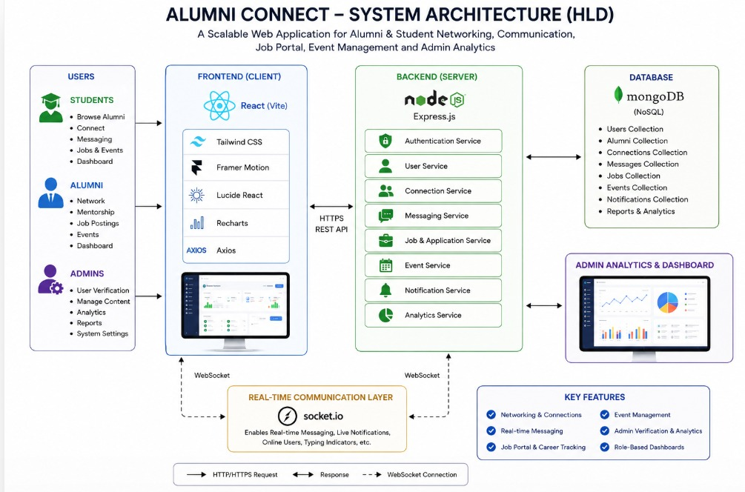

Figure 3.1: System Architecture Diagram

Database Design (ER Diagram / Schema)

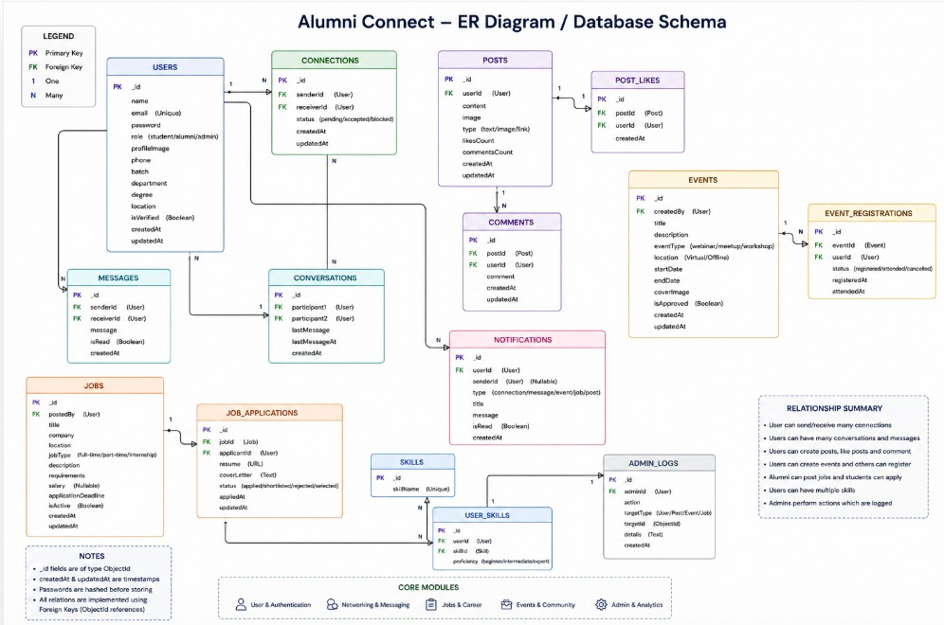

Figure 3.3: Entity Relationship Diagram

Module Description

No. | Module Name | Description
1 | User Authentication | Handles secure signup and login using JWT, bcrypt, and OTP verification.
2 | Alumni Profile Management | Allows alumni to create and manage professional profiles with verification badges
3 | Job and Internship Portal | Enables alumni to post opportunities and students to apply for jobs and internships.
4 | Search and File System | Students can search alumni by skills, company, department, and graduation year.
5 | Admin Management Module | Admin verifies alumni accounts, manages users, and monitors activities

IMPLEMENTATION

Technology Stack

Layer | Technology / Tool | Reason for Choice
Frontend | React.js, Tailwind CSS | Responsive and modern UI
Backend | Node.js, Express.js | Fast and Scalable backend
Database | MongoDB | Flexible NOSQL database
ML/AI Library | JWT, Bcrypt, OTP | Secure user authentication
Deployment | Firebase/ WebSockets | Instant notification

Implementation of Key Modules

Module 1: Authentication System
This module provides secure login and signup functionality using JWT authentication and bcrypt password encryption. OTP verification is used for password recovery.
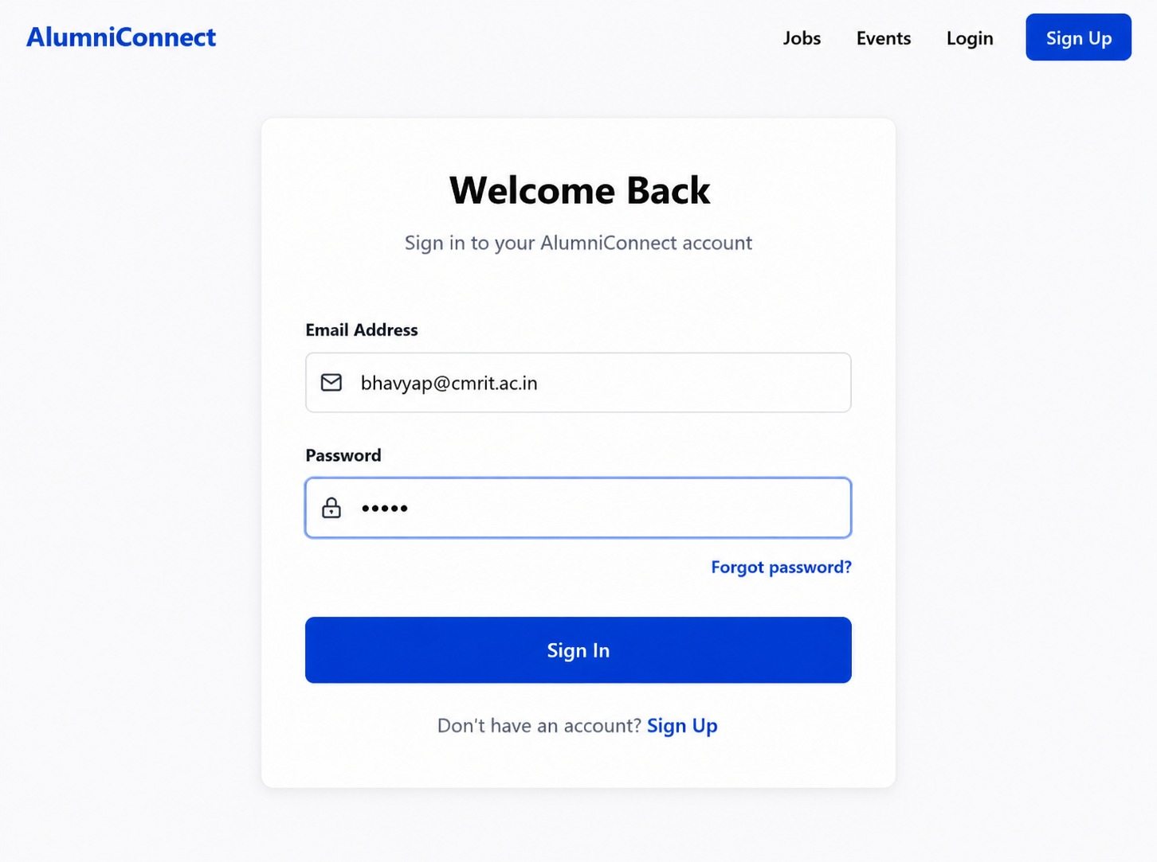

Figure 4.1: Login/Sign up Page

Module 2 : Alumni Profile Module

Verified alumni can create professional profiles including company details, job roles, skills, and achievements.

Module 3: Job & Internship Portal

Alumni can post opportunities dynamically into the database. Students can search, filter, and apply for jobs and internships.

Module 4: Webinar & Live Sessions

Alumni can host webinars and students can register and join sessions for career guidance and technical learning.

Module 5: Notification System

Students receive real-time updates for new jobs, webinars, and announcements using Firebase/ WebSockets.

Testing Methodology
The system was tested using unit testing and integration testing. Authentication, profile management, webinar registration, and job application modules were tested individually and as a complete system

RESULTS & DISCUSSIONS

Testing Methodology
The system was tested using unit testing and integration testing. Authentication, profile management, webinar registration, and job application modules were tested individually and as a complete system

Screenshots of Results


Figure 5.1:Login Page

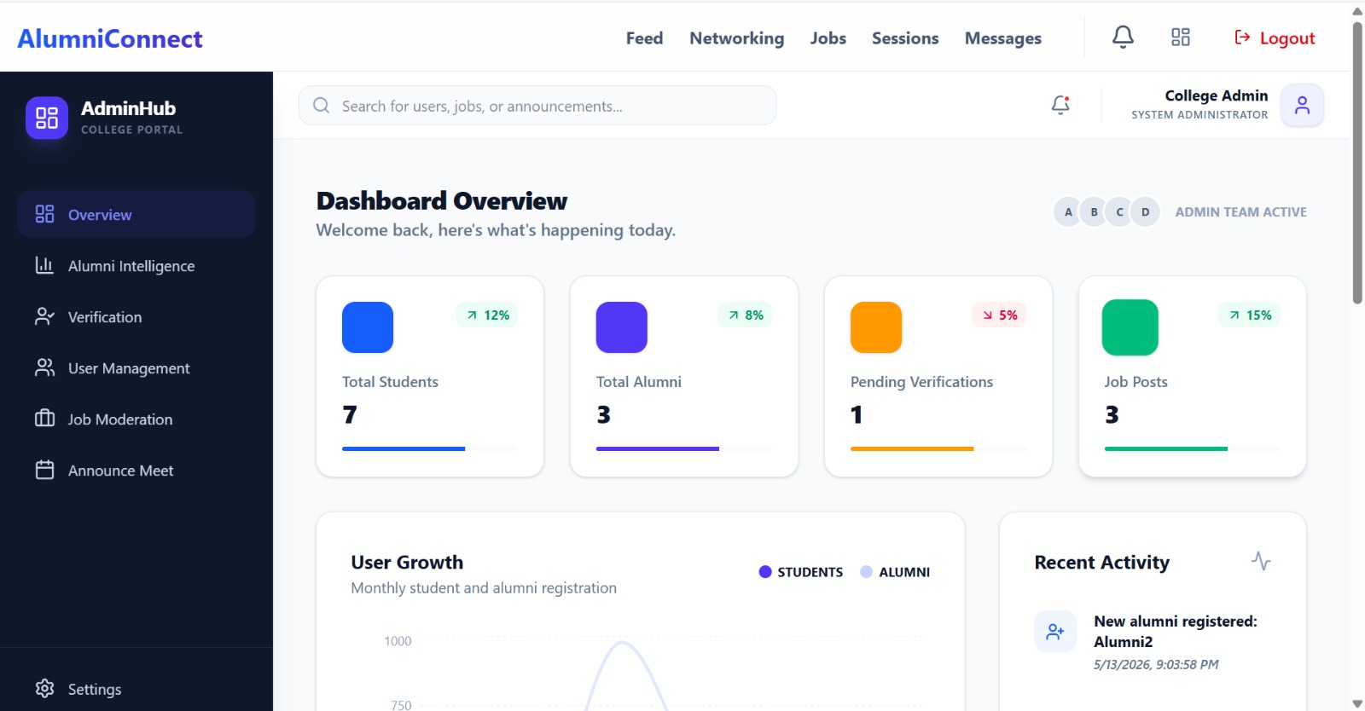

Figure 5.2: Admin Dashboard
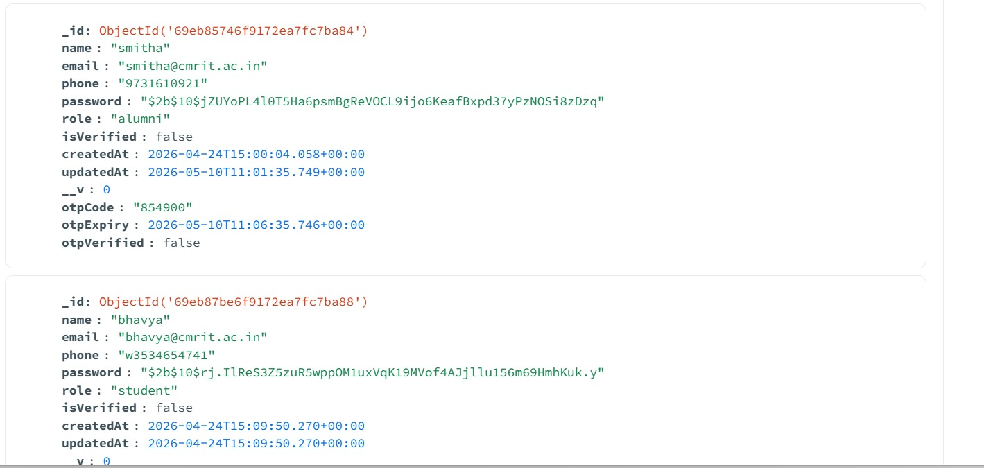

Figure 5.3 Output

Performance Evaluation
The platform successfully handles secure authentication, alumni verification, job postings, webinar registrations, and real-time updates efficiently.

Discussion

The Alumni Connect platform was developed to create a centralized ecosystem that strengthens communication and collaboration between students, alumni, and administrators. Traditional alumni management systems mainly focus on storing alumni records, whereas this project extends functionality by integrating professional networking, real-time communication, career support, event management, and administrative analytics into a single scalable platform.

The system successfully implements a role-based architecture where Students, Alumni, and Admins access different dashboards based on their permissions and responsibilities. This modular design improves usability, security, and maintainability.

One of the major strengths of the project is the integration of real-time communication using Socket.io. Unlike traditional systems that rely on static communication methods, this platform enables instant messaging, live notifications, and interactive engagement between users. This significantly improves networking efficiency and user interaction.

The platform also enhances career development opportunities through its Job Portal and Career Tracking Module. Alumni can post internships and job opportunities, while students can apply directly and monitor application progress. This creates a direct bridge between academia and industry.

The Event Management System simplifies the organization of alumni meets, webinars, workshops, and networking events. Attendance tracking and registration management help improve event coordination and participation monitoring.

From an administrative perspective, the Admin Dashboard provides advanced analytics and verification systems. Administrators can monitor user activity, verify alumni authenticity, manage reports, and moderate content effectively. Data visualization through charts and graphs helps in better decision-making.

The frontend implementation using React, Tailwind CSS, and Framer Motion delivers a modern and responsive user interface. Smooth animations, dashboard transitions, and interactive layouts improve the overall user experience and platform engagement.

The use of the MERN stack architecture ensures scalability, modularity, and efficient API communication. MongoDB’s flexible schema design supports dynamic data handling for social interactions, messaging, events, and job applications.

Overall, the project demonstrates how modern full-stack technologies can be combined to build a scalable, secure, and user-friendly alumni networking ecosystem.

Performance Evaluation
1. System Responsiveness

The React-based frontend with Vite bundling provides fast rendering and quick page navigation. Lazy loading and component-based rendering reduce unnecessary reloads and improve overall responsiveness.

Result:

- Faster UI rendering
- Smooth dashboard navigation
- Reduced page load time

2. Real-Time Communication Performance

Socket.io enables low-latency communication between users.

Features Evaluated:
- Instant messaging
- Typing indicators
- Live notifications

Result:
- Messages delivered in real time
- Minimal communication delay
- Improved user engagement

3. Database Performance
MongoDB efficiently handles:

- User records
- Connections
- Messages
- Events
- Job applications
Mongoose schema modeling improves query management and data validation.

Result:
- Fast CRUD operations
- Flexible data storage
- Efficient handling of dynamic social data

4. Authentication & Security Evaluation

JWT authentication and protected middleware were tested for secure access control.

Security Features:
- Token-based authentication
- Password hashing using bcrypt
- Role-based authorization
- Protected API routes

Result:
- Secure login sessions
- Prevention of unauthorized access
- Safe handling of user credentials

5. Dashboard Performance

The platform contains three independent dashboards:
- Student Dashboard
- Alumni Dashboard
- Admin Dashboard

Each dashboard dynamically loads only role-specific data.

Result:
- Reduced unnecessary API calls
- Better memory optimization
- Faster dashboard rendering

6. Analytics and Visualization Efficiency

Recharts was used for graphical data representation in the Admin Dashboard.
Evaluated Metrics:
- User activity
- Event participation
- Job statistics
- Platform engagement

Result:
- Interactive and responsive charts
- Easy interpretation of platform statistics
- Improved administrative monitoring

Conclusion
Alumni Connect successfully provides a secure and professional environment for students and alumni interaction. The platform enables career guidance, opportunity sharing, webinars, and alumni engagement.

The project helped in understanding full-stack web development, authentication systems, database management, and real-time communication.

Limitations
1. Mobile application support is not available.

2. Al-based recommendations are not implemented.

3. Video conferencing integration is limited.

4. Requires internet connectivity.

Future Scope
1. Development of Android and iOS applications

2. Al-based job recommendation system

3. Integrated video conferencing support

4. Cloud deployment for scalability

5. LinkedIn and email integration

REFERENCES

1. https://gravyty.com/community

2. https://www.almabase.com

3. https://hivebrite.io

4. https://www.almaconnect.com

5. https://react.dev

6. https://alumni-connect.in

7. https://www.nic.gov.in/nic-alumni-connect

8. https://jwt.io/introduction

9. https://firebase.google.com/

10. https://www.npmjs.com/package/bcrypt

APPENDIX A: SOURCE CODE
GitHub Repository: https://github.com/smithachash/alumniconnect

FILES
frontend/src/App.js

backend/server.js

models/User.js

routes/authRoutes.js
APPENDIX B: ADDITIONAL SCREENSHOTS
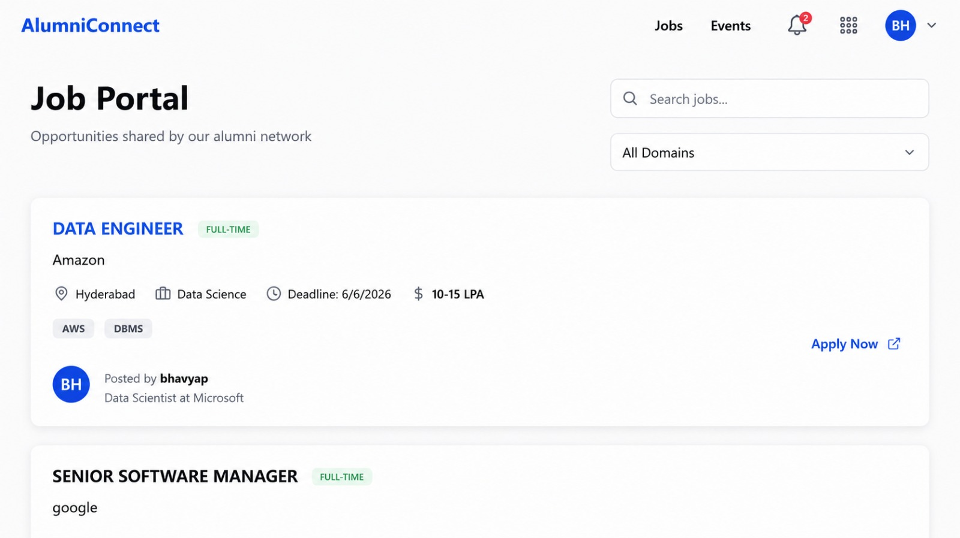

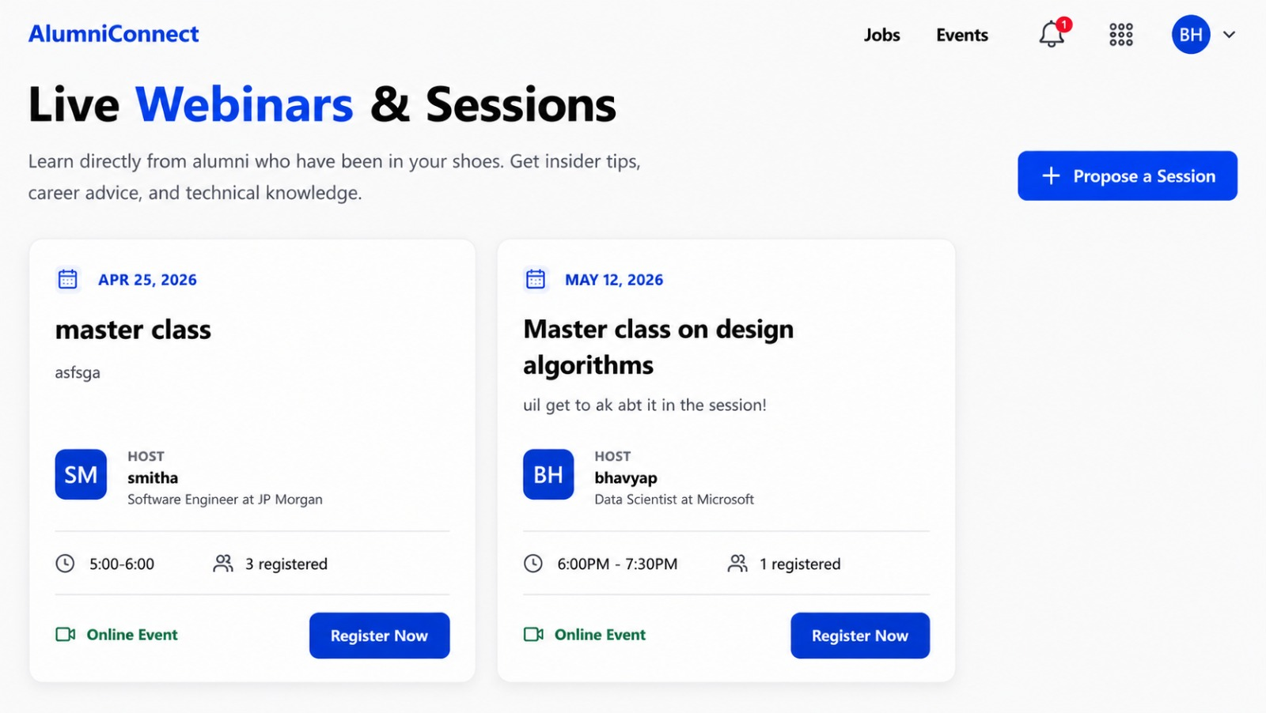

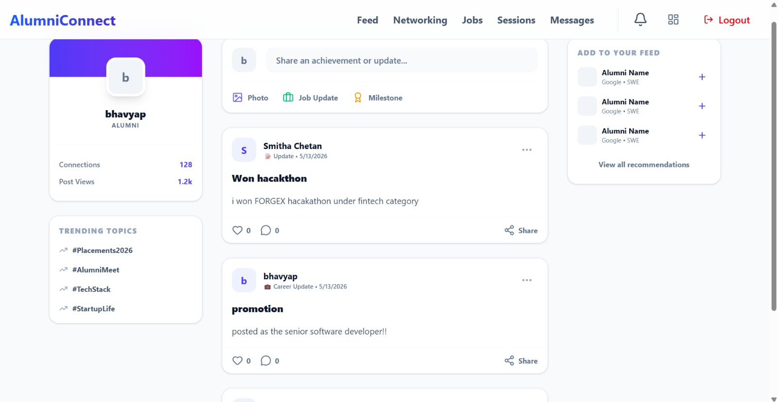
Alumni dashboard
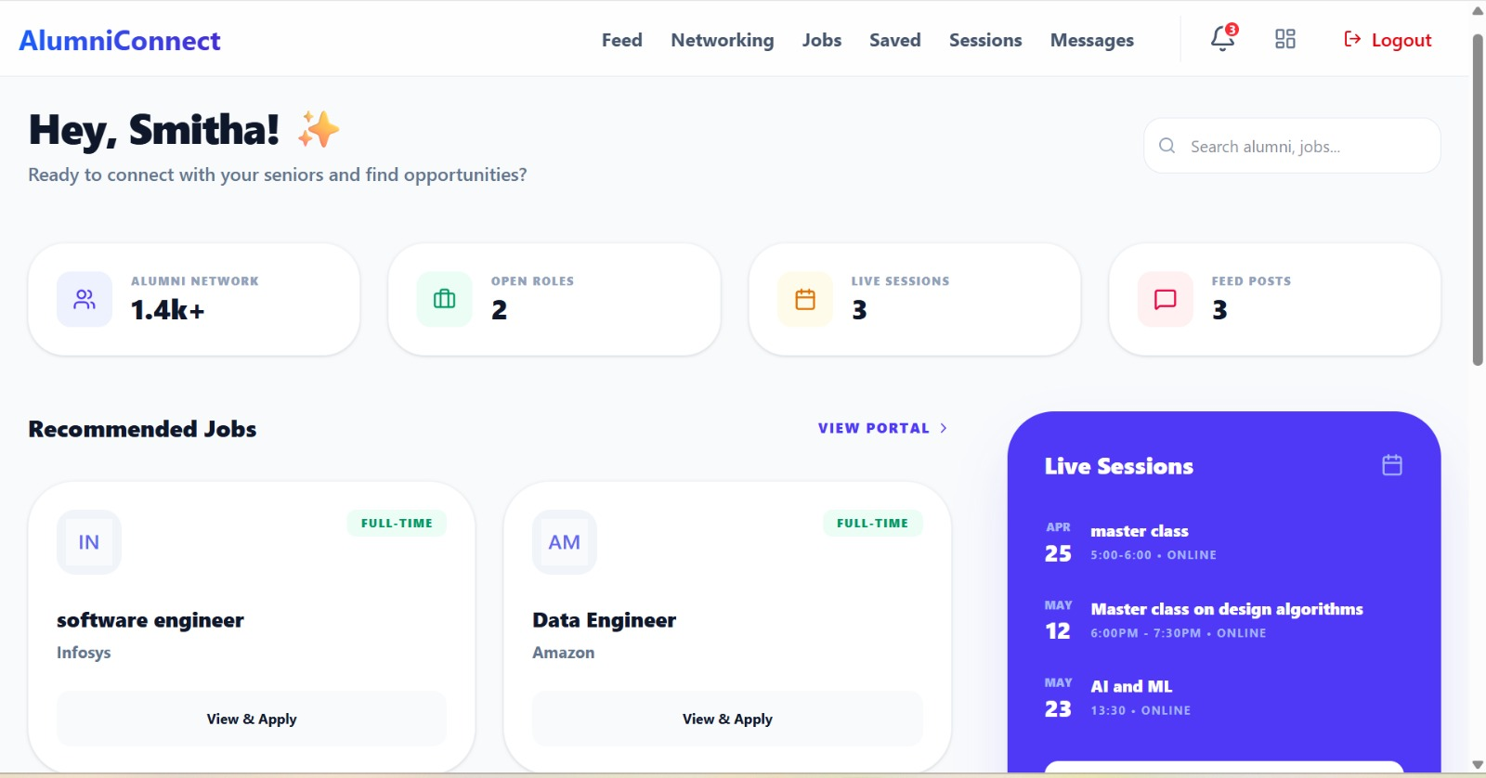

Student Dashboard

